Chapter – 4 Network Layer: Data Plane
- Network layer: overview • data plane • control plane
1. Network-layer Services and Protocols
- Main service: Deliver transport layer segments from sender host → receiver host.
- Sender side:
  - Takes transport segment -> Encapsulates it into a datagram -> Passes it to the link layer.
- Receiver side:
  - Gets datagram from link layer -> Extracts transport segment -> Passes it to the transport layer protocol (like TCP/UDP).
👉 Every Internet device (hosts + routers) runs network-layer protocols.
- Routers (extra role):
  - Look at header fields of datagrams.
  - Move them from input port → output port, step by step, along the end-to-end path.
2. Two Key Functions of Network Layer
- Forwarding
  - Inside a router: Move packets from input link → correct output link.
  - Happens locally, per router.
  - Analogy → Like passing through one traffic interchange.
- Routing
  - Decides the path/route packets take from source to destination.
  - Uses routing algorithms.
  - Happens globally, across the network.
  - Analogy → Like planning your whole trip from home to destination.
3. Data Plane vs Control Plane
Data Plane
- Local, per-router function.
- Decides how to forward a datagram that arrives on an input port → output port.
- Uses the packet header values (like destination IP) for the decision.
- Example: If header bits are 0111, router checks forwarding table → sends to output port 1, 2, or 3.
Control Plane
- Network-wide logic.
- Decides which route datagrams should take across multiple routers (end-to-end).
- Two approaches:
1. Per-Router Control Plane (Traditional)
- Each router has a routing algorithm component.
- Routers interact with each other in control plane.
- Each router independently computes its forwarding table.
- Uses traditional routing protocols: RIP, OSPF, BGP.
- ✅ Distributed, no single point of failure.
- ❌ Harder to manage in very large networks.

2. SDN Control Plane
- A remote (central) controller computes forwarding tables.
- Routers don’t run routing algorithms → only follow rules.
- Controller installs forwarding entries in routers (e.g., via OpenFlow).
- ✅ Centralized, flexible, programmable, easy network-wide control.
- ❌ Needs controller reliability (can be single point of failure).
✅ In simple words:
- Forwarding (Data Plane) = “Which exit to take at this intersection?”
- Routing (Control Plane) = “What’s the best path for the whole journey?”
What is a Network Service Model?
- Defines what kind of “channel” service the network provides for sending datagrams from sender → receiver.
Examples of Services
For individual datagrams:
- Guaranteed delivery (packet always arrives).
- Guaranteed delivery with delay bound (e.g., ≤ 40 ms).
For a flow of datagrams:
- In-order delivery (packets arrive in same order sent).
- Guaranteed minimum bandwidth for the flow.
- Restrictions on inter-packet spacing (avoid jitter).
Different Architectures and Their Service Models
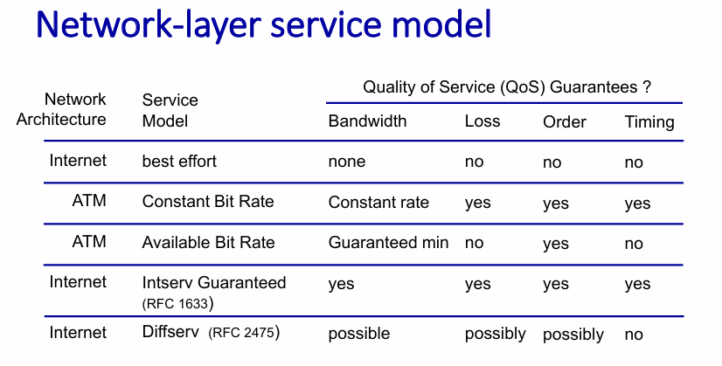
Reflections on Best-Effort Service (Internet)
- Simple design → easy to deploy, worldwide adoption.
- With enough bandwidth, real-time apps (voice, video) perform “good enough most of the time”.
- Distributed services (datacenters, CDNs) place servers closer to users → reduce delay.
- Congestion control (e.g., TCP) helps manage load for elastic apps (file transfer, browsing).
- Despite no guarantees, best-effort has been hugely successful.
✅ In simple words:
- The Internet’s best-effort model doesn’t promise anything (no guarantee of delivery, order, timing, or bandwidth).
- Yet, because of simplicity + extra mechanisms (like CDNs, congestion control, overprovisioning), it works well enough for most applications.

- What’s inside a router • input/output ports, switching • buffer management • scheduling
Router Architecture Overview
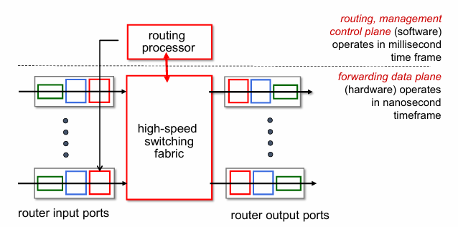

🛠️ High-Level Components of a Router
1. Input Ports
- Where packets enter the router.
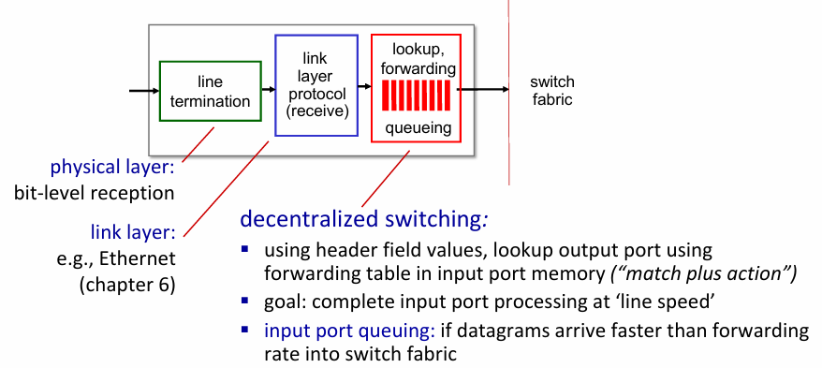
Decentralized Switching
  - Forwarding: Input port uses header fields to lookup output port in its forwarding table (“match + action”).
  - Goal: Process packets at line speed.
  - Input Queuing: Needed if datagrams arrive faster than switch fabric forwarding rate.
  - Forwarding Types:
    - Destination-based: Forward using only destination IP (traditional).
    - Generalized: Forward using any set of header fields.

Destination based forwarding
- Problem:
  - If address ranges don’t divide nicely or overlap:
    - A single range may need splitting into subranges.
    - Each subrange can be assigned to the correct port.
    - This may lead to more entries in the forwarding table.
- Key Idea:
- The router matches destination IP with the best range.
- Ensures packet goes to correct output port, even if ranges are irregular.
- Trade-off:
  - More irregular ranges → larger forwarding table, more lookup work.
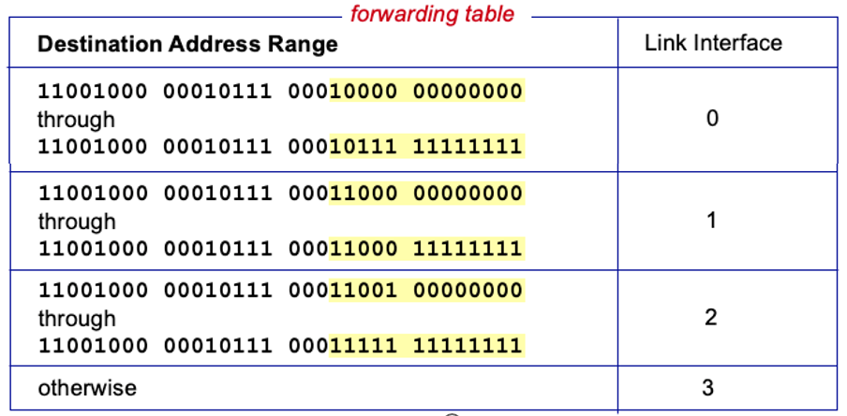
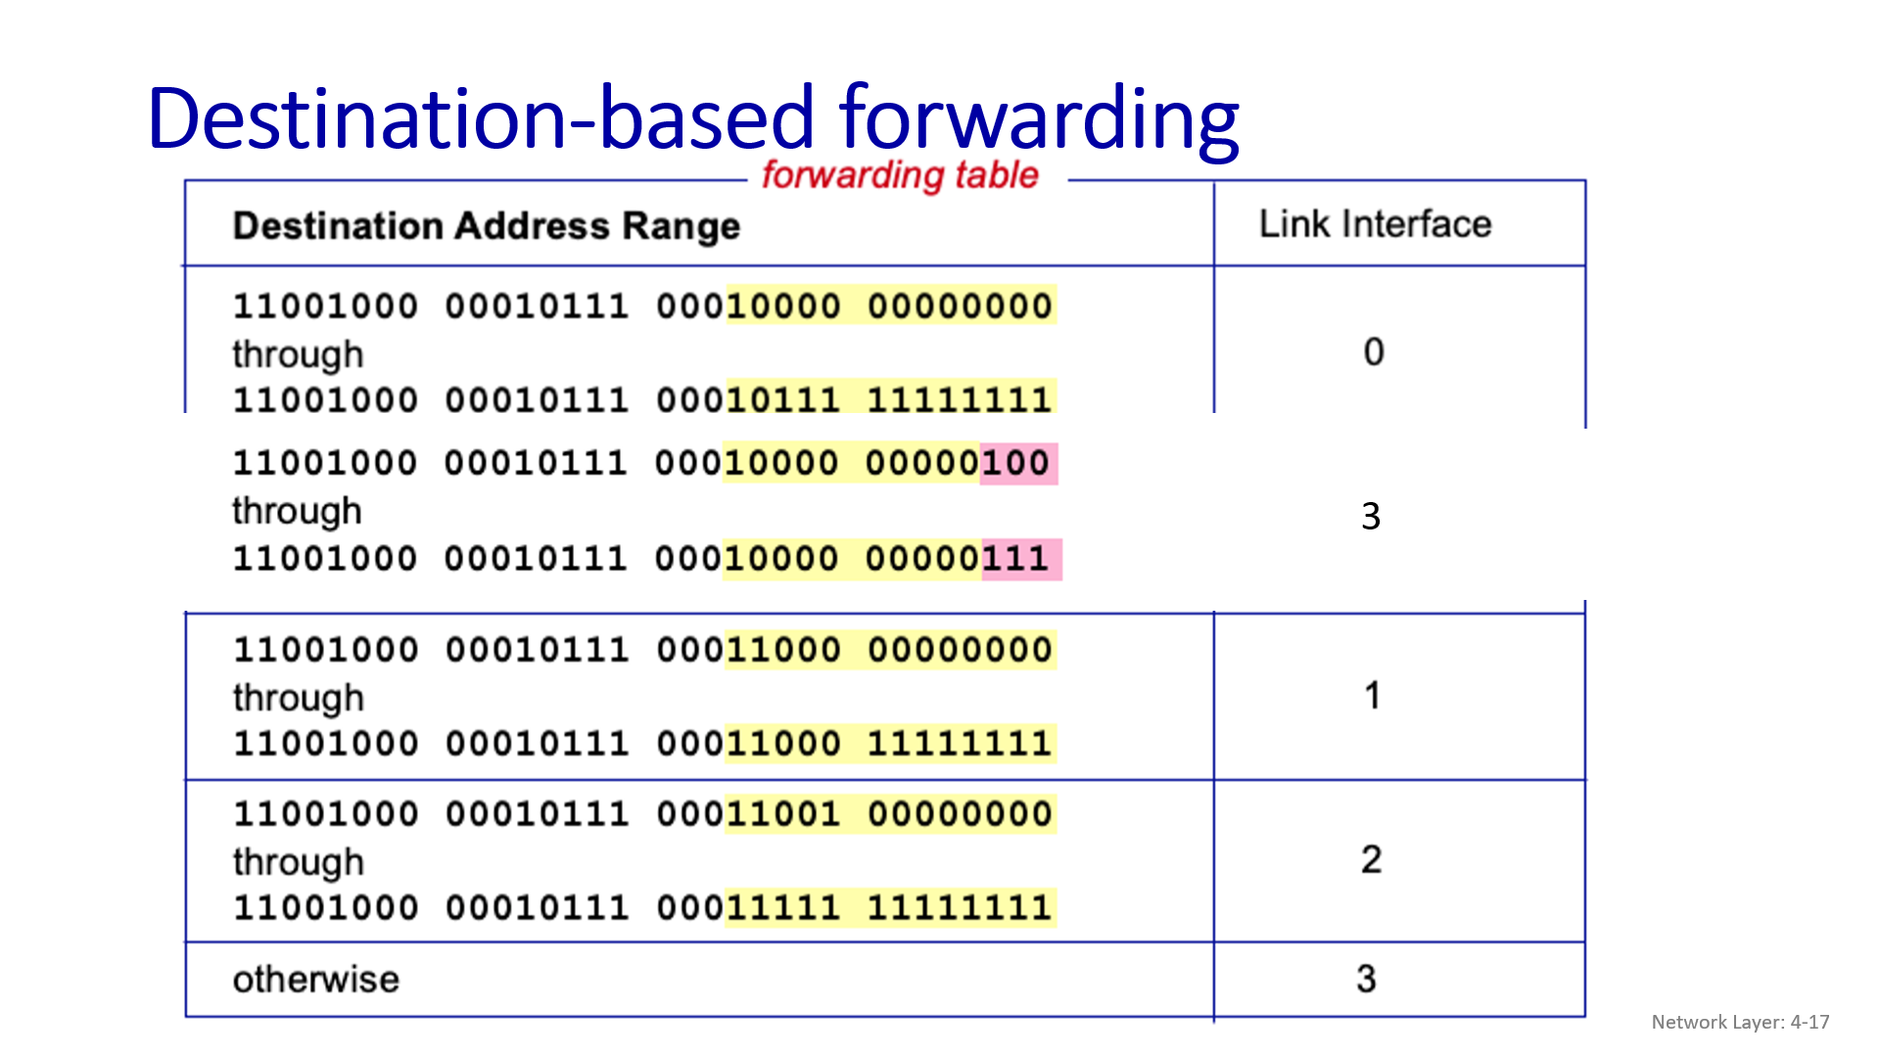

Longest Prefix Matching (LPM) – Notes
1. Concept:
- Used in forwarding tables to determine which output interface a packet should take.
- Rule: Choose the entry whose prefix matches the destination address and is longest (most specific).
2. Example Table:
Destination Prefix | Interface
11001000 00010111 00010*** ******** | 0
11001000 00010111 00011000 ******** | 1
11001000 00010111 00011*** ******** | 2
Otherwise | 3
3. Example Matches:
- Destination: 11001000 00010111 00010110 10100001 → Interface 3 (no longer prefix match)
- Destination: 11001000 00010111 00011000 10101010 → Interface 1 (matches longest prefix) (Orange one matched with link 2 but orange and blue (more length) matched with link 1)
4. Key Points:
- Ensures packets follow the most specific route.
- Helps when address ranges overlap.
- Often implemented using TCAM (Ternary Content Addressable Memory):
  - Lookup in one clock cycle, independent of table size.
  - Example: Cisco Catalyst supports ~1M entries.
2. Switching Fabric (Core of Router)
Purpose: Transfer packets from input link → appropriate output link.
Switching rate:
- Speed packets move from inputs → outputs.
- Desirable: N input ports → switching rate = N × line rate.

Types of Switching Fabrics:
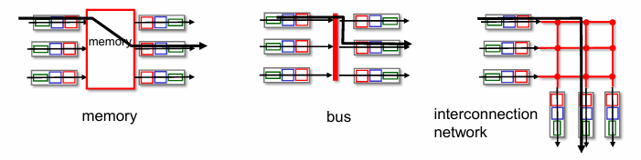
- Memory-based:
- First-gen routers: CPU controls switching.
- Packet copied to system memory.
- Speed limited by memory bandwidth (2 memory accesses per packet).
- Input port → memory → output port via system bus.
- Bus-based:
- Datagram moves input memory → output memory via shared bus.
- Bus contention limits speed.
- Example: Cisco 5600, 32 Gbps bus sufficient for access routers.
- Interconnection network-based:
- Uses crossbar, Clos networks, initially for multiprocessor connections.
- Multistage switch: nxn switch built from multiple smaller-stage switches.
- Parallelism:
- Fragment datagram into fixed-length cells at entry.
- Switch cells through fabric → reassemble at exit.
  - Scaling: multiple switching planes in parallel → speedup & higher capacity.
- Example: Cisco CRS router:
    - 8 switching planes, each = 3-stage interconnection network.
    - Can handle hundreds of Tbps switching capacity.
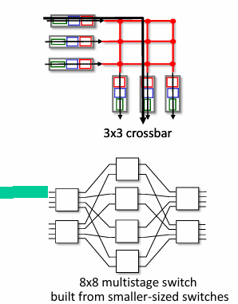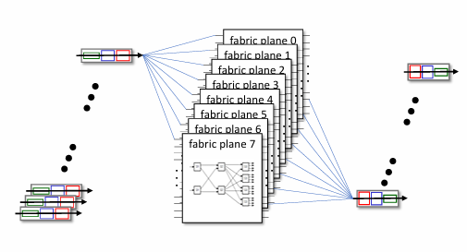
Input port queuing
Switch Fabric Limitations
- If switch fabric is slower than combined input ports → queueing at input queues.
  - Can cause queueing delay and packet loss (input buffer overflow).
- Head-of-the-Line (HOL) blocking:
  - Packet at front of queue blocks others behind it, even if their output ports are free.
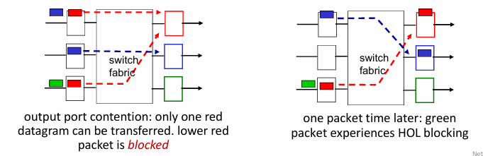
3. Output Ports
🖧 Router Output Port Queuing
🔹 1. Why Output Port Queuing is Needed
- When packets arrive at the output port faster than the link can transmit, they must wait in a buffer.
- Without buffering → packets are dropped (congestion).
🔹2. Key Points
- Buffering
  - Needed if arrival rate > link transmission rate.
  - Drop policy decides which packets to drop if buffer is full.
- Scheduling Discipline
  - Chooses which queued packet to send next.
  - Examples: FIFO, priority based.
  - Determines performance for different flows.
- Consequences of Output Queuing
  - Delay → packets wait in buffer.
  - Packet Loss → buffer overflow due to congestion.
  - Priority scheduling → some packets get faster service (network neutrality considerations).
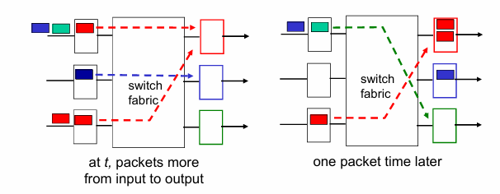
🖧 Output Port Buffering & Scheduling
1. How Much Buffering?
  - RFC 3439: Buffer ≈ RTT × Link Capacity
  - Example: 10 Gbps link, 250 ms RTT → 2.5 Gbit buffer.
  - Recent formula: With N flows → Buffer ≈ (RTT × C) / √N
  - Caution: Too much buffering → high delays, poor real-time performance, sluggish TCP.
  - Goal: Keep bottleneck link “just full enough, but no fuller.”
2. Buffer Management
- Drop policy: What to drop if buffer full:
  - Tail drop → drop arriving packet.
  - Priority-based drop → drop lower-priority packets first.
- Marking → signal congestion instead of dropping (e.g., ECN, RED).
3. Packet Scheduling
- Decide which packet to send next.
Policies
- FCFS / FIFO
- Send packets in order of arrival.
- Simple, common.
- Priority Scheduling
- Classify traffic into queues by priority.
- Always serve highest priority queue first.
- FCFS within each priority class.
- Round Robin (RR)
- Cyclically serve each class queue, one packet at a time.
- Weighted Fair Queuing (WFQ)
- Generalized RR with weights per class.
- Guarantees minimum bandwidth per traffic class.
- each class, i, has weight, wi, and gets weighted amount of service in each cycle:
- 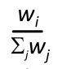
- minimum bandwidth guarantee (per-traffic-class)

⚖️ Sidebar: Network Neutrality
1. Definition
- Technical: How an ISP shares resources (packet scheduling, buffer management).
- Social/Economic:
  - Protect free speech.
  - Encourage innovation and competition.
- Legal: Enforced via policies and regulations, varies by country.
2. US FCC 2015 “Open Internet” Rules
- No Blocking → Cannot block lawful content, apps, services, or devices (reasonable management allowed).
- No Throttling → Cannot degrade lawful Internet traffic based on content, app, service, or device.
- No Paid Prioritization → Cannot give special priority to paid traffic.
3. ISP Regulatory Status
- Is ISP a Telecommunications Service or Information Service?
- Telecommunications Service (Title II)
  - Common carrier duties: reasonable rates, non-discrimination, regulated.
- Information Service (Title I)
  - No common carrier duties, less regulated, FCC has authority if needed.

4. Routing Processor
- Brain of the router.
- Runs routing protocols (RIP, OSPF, BGP).
- Computes the routing table → installs forwarding table into input ports.
- Also handles management functions (e.g., SNMP, configuration).

- IP: the Internet Protocol • datagram format, addressing • network address translation (NAT) • IPv6
📘 Internet Protocol (IP) – Notes
1. Network Layer Overview
- Functions of host/router network layer
  - Path-selection (routing):
    - Algorithms implemented in routing protocols (OSPF, BGP) or SDN controllers.
  - IP protocol tasks:
    - Forwarding table lookup.
    - Datagram format, addressing, packet handling conventions.
  - ICMP protocol:
    - Error reporting.
    - Router signaling.
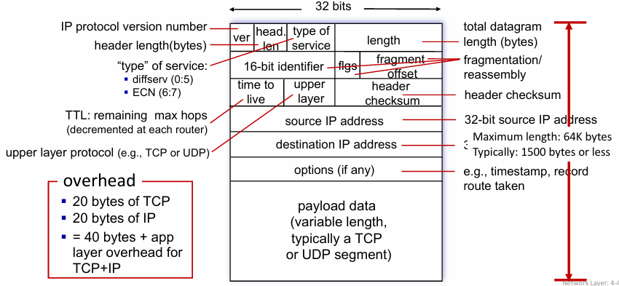

2. IP Addressing Basics
  - IP Address: 32-bit identifier assigned to each host or router interface.
  - Interface: Connection between host/router and physical link.
    - Router → multiple interfaces.
    - Host → usually 1–2 interfaces (e.g., Ethernet, Wi-Fi).
  - Notation: Dotted decimal (e.g., 223.1.1.1 = binary 11011111 00000001 00000001 00000001).

3. Subnets
- Definition:
  - Device interfaces that can physically reach each other without passing through a router.
- IP Address Structure:
  - Subnet part → common high-order bits.
  - Host part → remaining low-order bits.
- Subnet Formation Recipe:
  - Detach each interface from its host/router → isolated networks (islands).
  - Each isolated network = subnet.
- Example: Identify /24 subnet addresses within a given block.
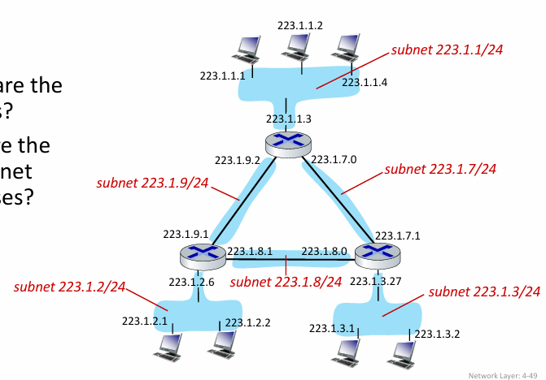
4. CIDR (Classless Inter-Domain Routing)
- Why CIDR? Replaces old class-based addressing.
- Format: a.b.c.d/x → x = number of subnet bits.
- Example: 200.23.16.0/23
  - Subnet part = first 23 bits.
  - Host part = remaining 9 bits.

5. How IP Addresses Are Obtained
- Two levels of allocation:
  - Host level (host part):
    - Hard-coded (e.g., /etc/rc.config in UNIX).
    - DHCP (Dynamic Host Configuration Protocol):
      - Host dynamically gets IP from DHCP server.
      - Plug-and-play, no manual configuration needed.
  - Network level (network part):
    - Allocated by ISP or higher authorities (e.g., IANA/Regional Internet Registries).
🖧 DHCP (Dynamic Host Configuration Protocol)
1. Goal
- Let’s a host (laptop, phone, etc.) automatically get an IP address when it connects to a network.
- Features:
  - Can renew the lease if still connected.
  - Allows reuse of addresses (IP is freed when device disconnects).
  - Great for mobile users who move between networks.
2. DHCP Working (Message Flow)
When a device joins the network:
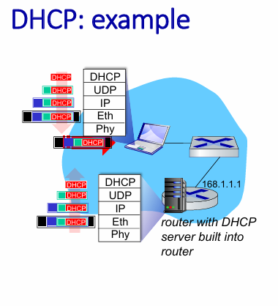
- DHCP Discover
- Host sends a broadcast message:
“Is there a DHCP server out there?”
- Source = 0.0.0.0:68 (device doesn’t have IP yet). (Port 68 is reserved for DHCP server only)
- Destination = 255.255.255.255:67 (broadcast).
- yiaddr (Your IP Address) = 0.0.0.0.
- Contains a transaction ID to match replies.
- DHCP Offer
- DHCP server replies (also as a broadcast):
“I am a DHCP server, you can use this IP!”
- Example: Server IP = 223.1.2.5.
- Offers IP = 223.1.2.4.
- Lifetime = 3600 seconds (1 hour).
- DHCP Request
- Host responds:
“Okay, I’d like to use this IP.”
- Broadcast again with chosen IP.
- Confirms transaction ID and lease time.
- DHCP Acknowledgment (ACK)
- Server confirms:
“Yes, you got this IP!”
- Host can now start using the address.
3. Optimizations
- If a host remembers its old IP, it can skip Discover/Offer and directly request that address (if still valid).
- Defined in RFC 2131.
4. DHCP Provides More Than IP Address
DHCP can also send:
- Address of first-hop router (default gateway).
- Name and IP of DNS server.
- Subnet mask (to know network vs host portion).
DHCP: example
- Connecting laptop will use DHCP to get IP address, address of first hop router, address of DNS server.
- DHCP REQUEST message encapsulated in UDP, encapsulated in IP, encapsulated in Ethernet
- Ethernet frame broadcast (dest: FFFFFFFFFFFF) on LAN, received at router running DHCP server
- Ethernet de-mux’ed to IP de-mux’ed, UDP de-mux’ed to DHCP
- DCP server formulates DHCP ACK containing client’s IP address, IP address of first-hop router for client, name & IP address of DNS server
- Encapsulated DHCP server reply forwarded to client, de-muxing up to DHCP at client
- Client now knows its IP address, name and IP address of DNS server, IP address of its first-hop router
🌍 How Does a Network Get Its Subnet Part of IP Address?
1. Allocation from ISP
- A network (organization, university, company, etc.) does not randomly choose an IP.
- Its ISP (Internet Service Provider) allocates a portion of its own larger address block.
- Example:
  - ISP has block: 200.23.16.0/20
  - This /20 block = 4096 addresses (from 200.23.16.0 to 200.23.31.255).

2. Subdivision into Smaller Blocks
- ISP can divide its /20 block into smaller sub-blocks (subnets).
- Example: splitting /20 into eight /23 blocks:
Organization | Binary Prefix (Subnet Bits) | Address Block
Org 0 | 200.23.16.0/23 | (200.23.16.0 – 200.23.17.255)
Org 1 | 200.23.18.0/23 | (200.23.18.0 – 200.23.19.255)
Org 2 | 200.23.20.0/23 | (200.23.20.0 – 200.23.21.255)
Org 3 | 200.23.22.0/23 | (200.23.22.0 – 200.23.23.255)
Org 4 | 200.23.24.0/23 | (200.23.24.0 – 200.23.25.255)
Org 5 | 200.23.26.0/23 | (200.23.26.0 – 200.23.27.255)
Org 6 | 200.23.28.0/23 | (200.23.28.0 – 200.23.29.255)
Org 7 | 200.23.30.0/23 | (200.23.30.0 – 200.23.31.255)

Hierarchical Addressing & Route Aggregation
- Purpose: Makes routing scalable by allowing ISPs to aggregate multiple subnets into a single advertisement.
- Example:
  - Organizations under Fly-By-Night-ISP:
    - Org0 → 200.23.16.0/23
    - Org1 → 200.23.18.0/23
    - Org2 → 200.23.20.0/23
    - … up to Org7 → 200.23.30.0/23
  - Fly-By-Night-ISP advertises: “Send me anything with addresses beginning 200.23.16.0/20.”
  - ISPs-R-Us advertises: “Send me anything with addresses beginning 199.31.0.0/16.”
More Specific Routes
- If Organization 1 moves from Fly-By-Night-ISP to ISPs-R-Us:
  - ISPs-R-Us must advertise 200.23.18.0/23 (a more specific route).
  - Internet routers now have:
    - General route → 200.23.16.0/20 (Fly-By-Night-ISP).
    - Exception → 200.23.18.0/23 (ISPs-R-Us).
Result:
  - Hierarchical aggregation reduces routing table size.
  - More specific routes are used for exceptions.
🛡️ NAT – Network Address Translation
1. What is NAT?
- NAT allows all devices in a local network (like your home or office) to share a single public IPv4 address when communicating with the outside Internet.
- Example:
- Local network (private IPs): 10.0.0.0/24 → devices 10.0.0.1, 10.0.0.2, 10.0.0.3, 10.0.0.4.
- Public NAT IP (used outside): 138.76.29.7.
- Outgoing datagrams: all use the same NAT IP, but with different source port numbers to distinguish devices.
- Within the local network: devices still use their private IPs normally.
2. Private IP Address Space
- Devices in local networks use private IP ranges:
  - 10.0.0.0/8
  - 172.16.0.0/12
  - 192.168.0.0/16
- These addresses cannot be routed on the Internet, only inside the local network.
3. Advantages of NAT
- Saves public IPs: only one public IP needed for many devices.
- Flexible internal addressing: you can change local device addresses without notifying the outside world.
- ISP independence: switch ISP without changing local device IPs.
- Security: devices inside the network are not directly visible from the Internet.
4. How NAT Works (Implementation)
- NAT is usually implemented in the router connecting the local network to the Internet.
Outgoing Datagrams
- Router replaces (source IP, source port) of each outgoing packet with (NAT IP, new port).
- Keeps a translation table:
- (local IP, local port) → (NAT IP, new port)
- Remote servers respond to (NAT IP, new port).
Incoming Datagrams
- Router looks up the translation table.
- Replaces (NAT IP, port) in incoming packet with the original local IP and port.
- Delivers packet to the correct device inside the network.
NAT: Network Address Translation
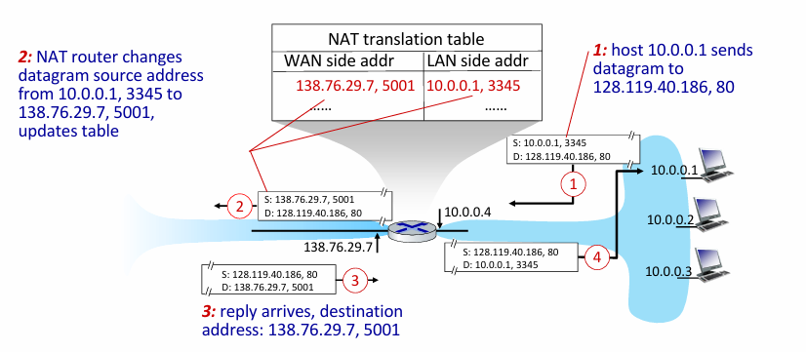
- advantages:
  - just one IP address needed from provider ISP for all devices
  - can change addresses of host in local network without notifying outside world
  - can change ISP without changing addresses of devices in local network
  - security: devices inside local net not directly addressable, visible by outside world
NAT (Network Address Translation)
- Controversies:
- Routers ideally should process only up to Layer 3.
- IPv6 is meant to solve the IP address shortage, making NAT theoretically unnecessary.
- Violates end-to-end principle: NAT manipulates port numbers, which is done by network-layer devices rather than endpoints.
- NAT traversal issues: Connecting to servers behind NAT can be tricky.
- Reality:
  - NAT is widely used in practice:
  - Home networks
  - Institutional networks
  - 4G/5G cellular networks
IPv6: Motivation
- Initial motivation: IPv4’s 32-bit address space would eventually run out.
- Additional motivations:
  - Faster processing/forwarding: Fixed 40-byte header.
  - Flow-based handling: Allows network-layer differentiation of “flows”.
What’s missing compared with IPv4
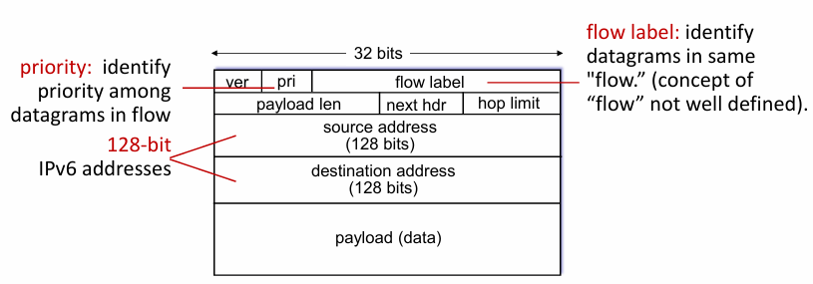
- No checksum → speeds up router processing.
- No fragmentation/reassembly.
- No options → handled via upper-layer “next-header” protocols.
Transition from IPv4 to IPv6
- Challenges:
  - Not all routers can be upgraded simultaneously → no “flag days”.
  - Networks must operate with mixed IPv4 and IPv6 routers.
- Solution: Tunnelling
  - IPv6 datagram carried as payload inside IPv4 datagram (“packet within a packet”).
  - Widely used in 4G/5G networks and other contexts.
Tuneling and Encapsulation
1. Ethernet connecting two IPv6 routers
- Normal case:
  - IPv6 datagram → directly carried as payload in link-layer Ethernet frame.
  - Source → Destination: A → B, Ethernet simply delivers the IPv6 datagram.
2. IPv4 network connecting two IPv6 routers
- IPv6 routers cannot communicate natively over an IPv4-only network.
- Solution: Tunneling
  - IPv6 datagram is encapsulated inside an IPv4 datagram.
  - Logical flow remains A → F (end-to-end IPv6).
  - Physical transmission: IPv4 network carries IPv6 inside IPv4 packets.
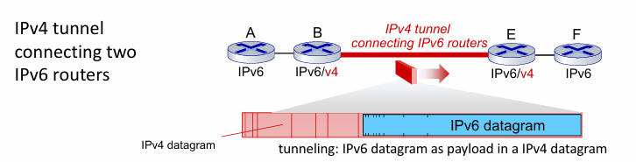

Flow Example:
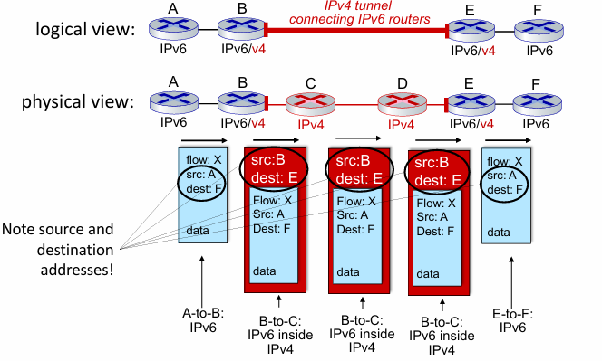
IPv6 Adoption
- Google (2023): ~40% of clients access services via IPv6.
- NIST: 1/3 of US government domains IPv6 capable.
- Deployment is slow:
  - 25+ years and still ongoing.
  - Applications have evolved (WWW, social media, streaming, gaming, telepresence) → adoption complexity.

- Generalized Forwarding • Match + action • OpenFlow • Middleboxes
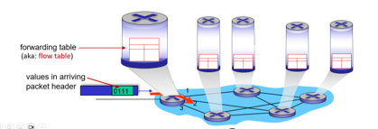
Generalized Forwarding: Match + Action
- Routers/switches use a forwarding table.
- Concept: “Match bits in packet → take action”.
- Destination-based forwarding: Based on destination IP.
- Generalized forwarding:
  - Match on many header fields (link, network, transport).
  - Actions: drop, forward, modify, log, or send packet to controller.

Flow Table Abstraction
- Flow: Set of packets defined by header fields (link, network, transport).
- Flow table entry:
  - Match: Pattern on header fields.
  - Action: What to do if matched (forward, drop, modify, send to controller).
  - Priority: Resolve overlapping patterns.
  - Counters: Track number of bytes/packets.

OpenFlow: Flow Table Entries

OpenFlow Examples
- Destination-based forwarding: Forward IP 51.6.0.8 → port 6
- Firewall: Drop all packets destined to TCP port 22 (SSH)
- Host-based filtering: Drop packets sent by host 128.119.1.1
- Layer 2 forwarding: Forward frames with destination MAC 22:A7:23:11:E1:02 → port 3

Unified Abstraction (Match + Action)
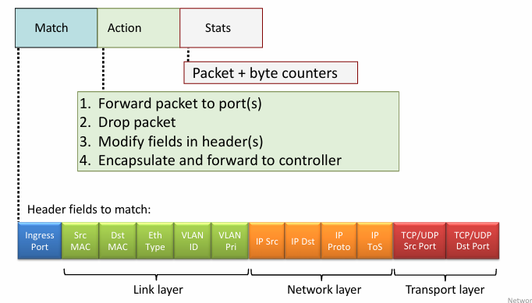
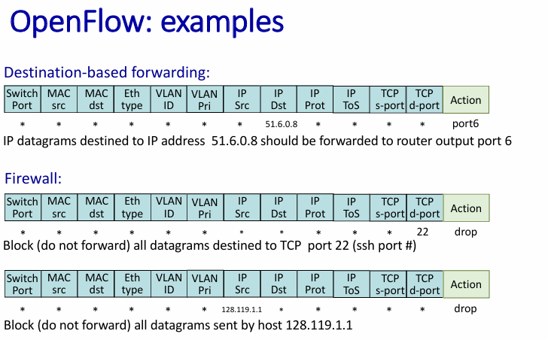
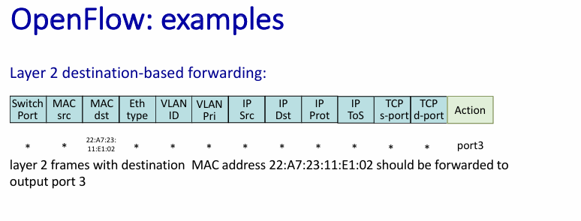
OpenFlow abstraction
Device | Match Fields | Action
Router | Longest destination IP prefix | Forward out a specific link
Switch | Destination MAC address | Forward or flood
Firewall | IP addresses + TCP/UDP port numbers | Permit or deny (drop)
NAT | IP address + port | Rewrite address and port
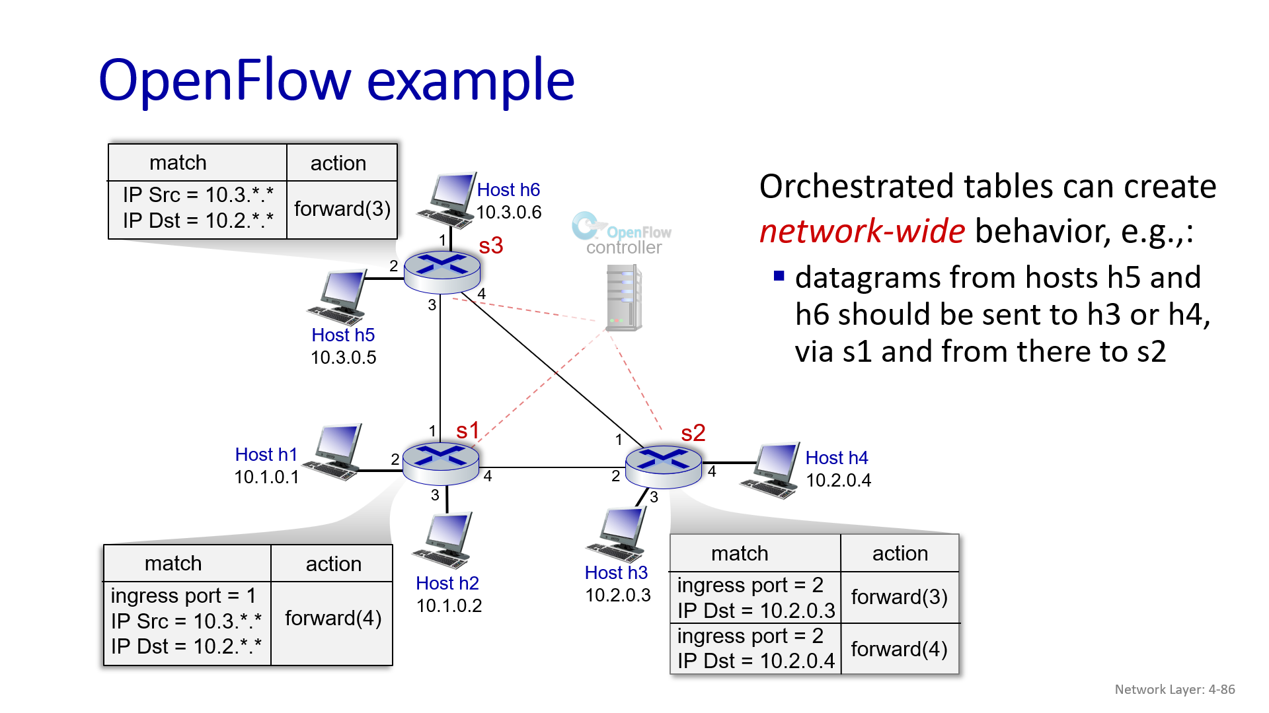
- Internet architecture
IP Hourglass
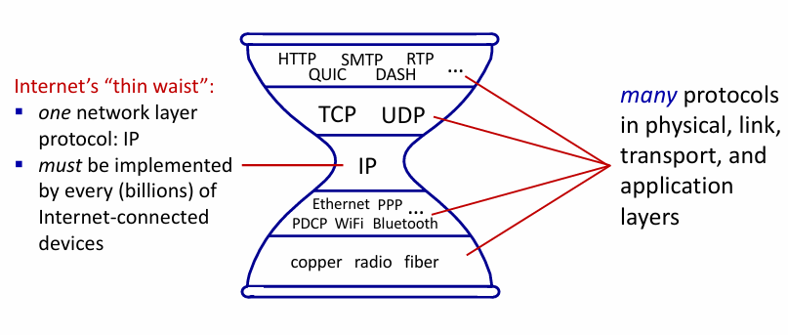
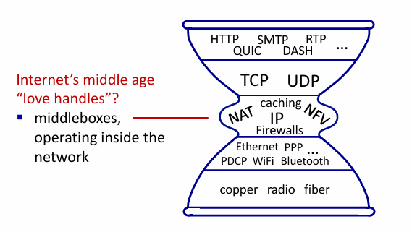
Architectural Principles of the Internet
Three cornerstone beliefs:
  - simple connectivity
  - IP protocol: that narrow waist
  - intelligence, complexity at network edge
The end-end argument
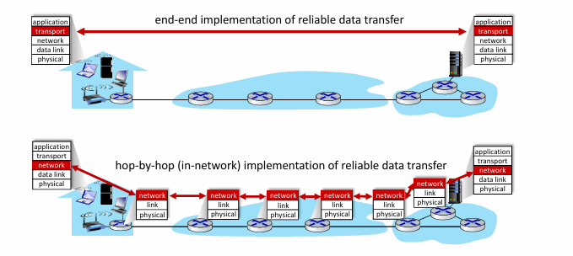
End-to-End Argument (Saltzer, Reed, Clark 1981)
- Idea: Some network functions—like reliable data transfer or congestion control—can be implemented either:
  - Inside the network (hop-by-hop)
  - At the network edges (end-to-end, in applications)
- Key insight:
  - Complete and correct implementation often requires endpoint knowledge.
  - Implementing such functions only inside the network cannot guarantee correctness.
  - In-network implementations may provide performance improvements, but not full correctness.
- Implication:
  - Keep the network simple.
  - Place intelligence and complexity at the endpoints.
- Example:
  - Reliable data transfer can be done hop-by-hop in-network or end-to-end in applications but end-to-end ensures correctness.

Questions
1.Consider a datagram network using 8-bit host addresses which uses longest prefix matching in the forwarding tables of the routers. For the following forwarding table in a router with four interfaces, give the associated range of destination host addresses whose datagrams get forwarded using these respective interfaces and give the number of addresses in these ranges
Prefix | Interface
1*** **** | 0
11** **** | 1
111* **** | 2
Otherwise | 3

2.An Internet Service Provider (ISP) has the following chunk of CIDR-based IP addresses available with it: 245.248.128.0/20. This ISP wants to give a quarter of its addresses to Organization A, a quarter to Organization B, a quarter to Organization C and retains the remaining addresses with the ISP. Give a valid allocation of addresses to organizations A, B, and C
3. Consider the allocation of addresses in the previous question. Show the entries in the routing table on router X of the ISP that connects organizations A, B, and C on different ports of router X. Assume that router X is connected to router Y in the ISP network. Show the entry in the routing table on router Y with respect to the address allocated to Organizations A, B, and C. If organization B is moved to another ISP with the addresses that are allocated to it, what modifications are to be made in the routing table entries on Router X and Router Y.
4. Consider a NAT in a private network 192.168.1.0/24 with a single public IP 203.0.113.5. The private network has three devices, Device 1 (192.168.1.10). Device 2 (192.168.1.20), and Device 3 (192.168.1.30). Now, Device I and Device 2 connect to a web server at 198.51.100.25 80 while Device 3 connects to another web server at 198.51.200.25 80. Explain the NAT translation process, considering that each con-nection from a private IP (192.168.1.10, 192.168.1.20. 192.168.1.30) will be assigned the public IP 203.0.113.5 while communicating with the outside network.
5.Consider the SDN OpenFlow network shown below. Give the entries in the flow tables on packet switches st. s2 and s3 such that any datagrams striving with a source address of li3 or 4 are routed to the destination hosts specified in the destination address field in the IP datagrams. Your forwarding table rules should inchude the cases in which an arriving datagram destined for a directly attached host of the routers should be forwarded to a brighboring router for eventual delivery to the respective host. You may assume the path that the datagrams must take to reach the final destination
6.Consider a network where a device in Network A (IP address: 192.168.1.10) wants to send a large packet to a device in Network B (IP address 192.168.2.20). The packet is 3000 bytes in size, but the MTU (Maximum Transmission Unit) of the link between routers is 1500 bytes. Explain how the original IP packet is transmitted over the network with an MTU of 1500 bytes using IP fragmentation. Explain how the IP fragments are created with the key fields in the IP header and explain how the fragmented packets are reassembled at the destination.

